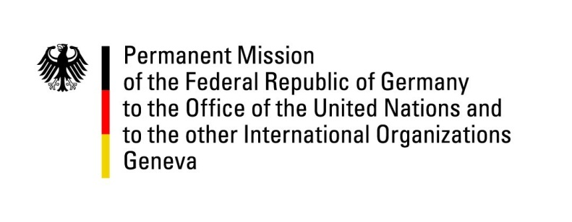

39th Session of the United Nations Human Rights Council

Geneva, 19 September 2018

Item 5 – Human Rights bodies and mechanisms:

ID with ASG Gilmour on Reprisals

German Statement

Mr. President,
Germany fully aligns itself with the statement made by the European Union.
We would like to thank Assistant Secretary-General Andrew Gilmour for his important work and commend him for his report highlighting reprisals against individuals who seek to cooperate or have cooperated with the United Nations, its representatives and mechanisms in the field of human rights.
We are deeply concerned by the growing number of acts of intimidation, harassment and reprisal. We are also profoundly disturbed by the trend of using alleged national security and counter-terrorism strategies to limit the access of civil society organizations to the United Nations. The participation of civil society organizations in the United Nations is vital for the functioning of the UN system as a whole and in particular the human rights mechanisms. Intimidation and reprisals contribute to shrinking civil society space and deprive us all from listening to the important voices from the grass roots.
In this context, we are troubled by the fact that the Egyptian lawyer Mr. Ebrahim Metwally Hegazy was detained by Egyptian authorities in September 2017, apparently to prevent him from travelling to a session of the UN Working Group on Enforced Disappearances and is still in detention today.
Germany will continue to support efforts to create and maintain a safe and enabling space for civil society and human rights defenders in the United Nations. It is our collective responsibility to protect those cooperating and reaching out to the UN and to prevent acts of reprisals and intimidation.
Thank you, Mr. President.

